**Preparation and Maintenance of ZOHO Books for Dream Homes Reality**

**Project Team members: KOWSALYA. K, KAVISHRI. C, KAVITHA. J, KAVIYA.A**

**1.INTRODUCTION**

**1.1 Overview**

This project is deal with Dream Homes Reality, a construction company, uses ZOHO Books to track project expenses, manage subcontractor payments, and handle invoicing. They can generate estimates and invoices for clients, track job costing, and monitor the profitability of each project. ZOHO Books provides them with financial insights to make informed decisions.

**1.2 Purpose**

By maintenance of accounts in ZOHO Books, We have created the Items, Vendors creation, Preparation of Purchase Order, Purchase Invoice, Customer creation, Preparation of Sales order, Sales Invoice, creation of bank account, creation of new accounts, recording journal entries, recording expenses, recording bank receipts and payments and viewing of financial reports like Profit & Loss account, Balance sheet, GST Reports, Journal report, Account receivable summary report, Account payable summary report, etc.,

**2.Problem Defining & Design Thinking**

2.1 Empathy map

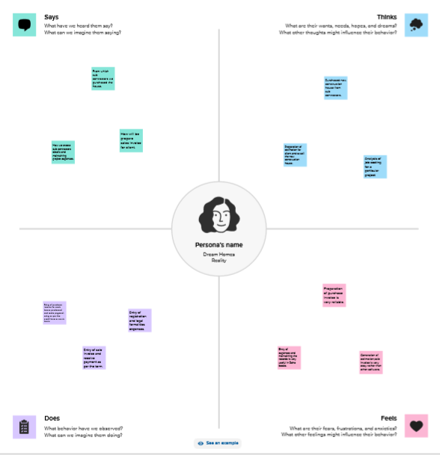

2.2 ideation &Brainstorming Map

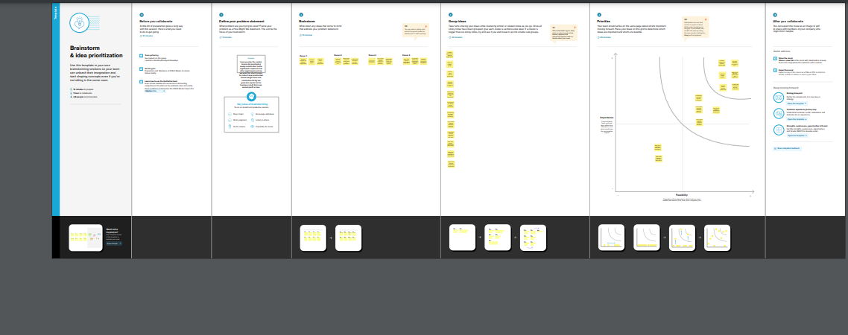

**3.RESULT**

To Generate the Financial Reports:

1. Profit and Loss Account:

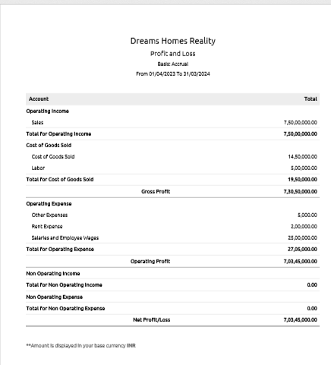

2.Balance Sheet

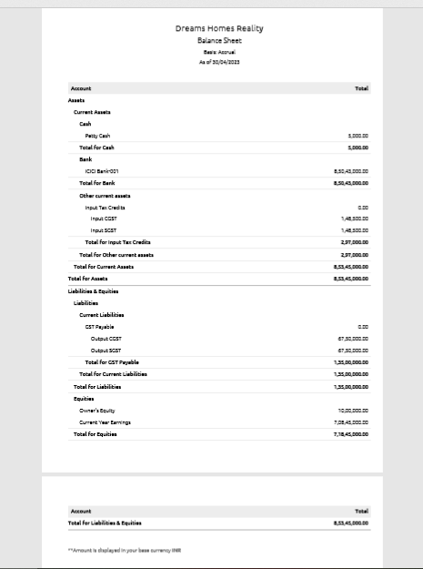

3.GST Reports

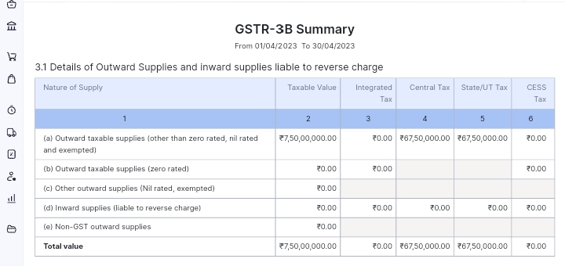

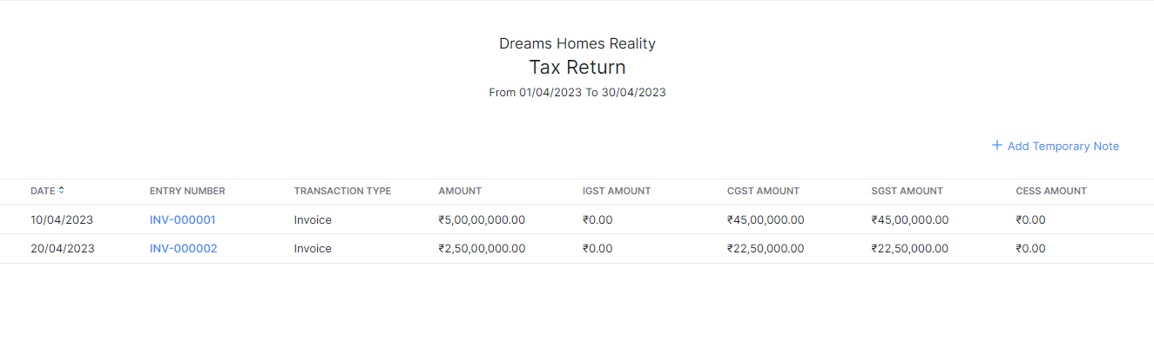

4. Journal Report

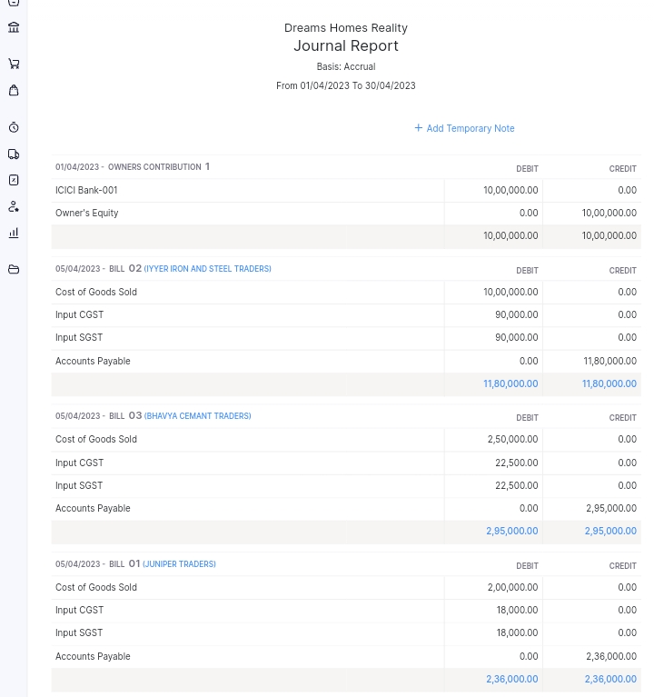

5. Accounts Receivable Summary

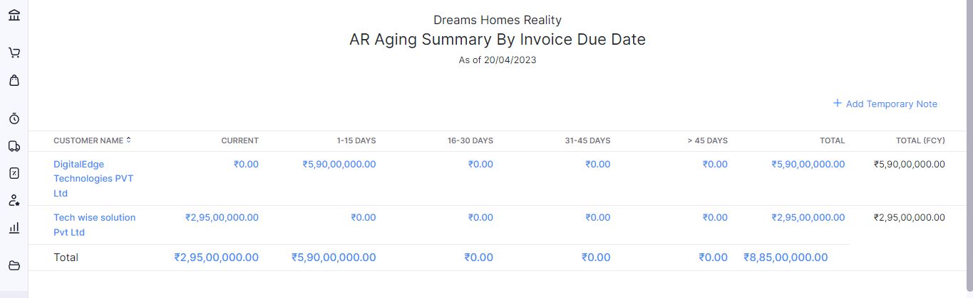

6. Accounts Payable Summary

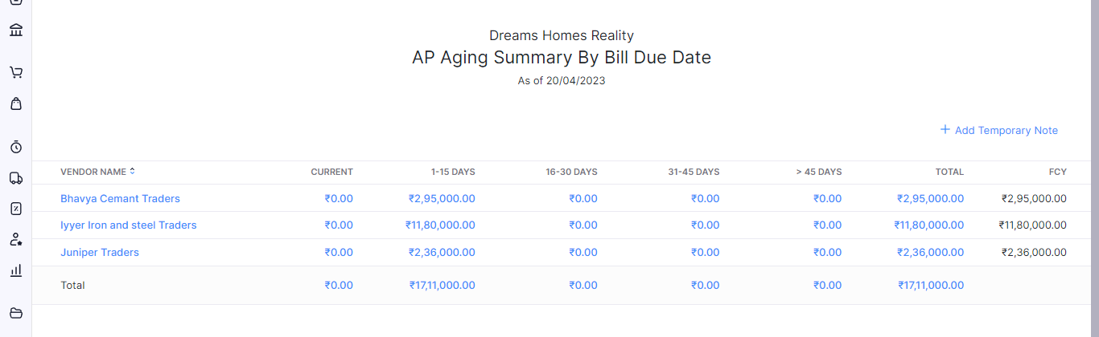

**4.ADVANTAGES & DISADVANTAGES**

List of advantages:

* ZOHO books is cloud based software, so we access the software in any location.
* Creating of Organization is very easy and user friendly.
* Appearance of software model is very easy to understanding.
* Creation of items, vendors, customers are user friendly while compare with software
* Preparation of purchase order and conversation to purchase Invoice made in a single step.
* Preparation of Sales order and conversation to Sale Invoice made in a single step.
* Default accounting step up is very useful and time saving.
* GST procedure is very easy to enter.
* Getting financial report and tax report in single step.

List of disadvantages:

* ZOHO books is cloud based software, which need internet and other technical facility.
* In absence of internet facility, the working in ZOHO books is very difficult.
* There is no secure in data of the organization.

**5.APPLICATIONS:**

The ZOHO Books is good software in all type of organization and we get better results instantly. We collect the following data and entered in ZOHO Books in various modules like item creation, Vendor creation, customer creation, preparation of Purchase order, Purchase Invoice, sales order, sale Invoice, making payment to vendors and Expenses, Received amount from Customers.

**Item creation:**

Let’s Assume Dream Homes Realty is offering below services:

1. Real Estate Development - Selling Price Rs. 5,000/- per sft.

It requires below Purchase items for the supply of above services:

1. Bricks (Cost price is Rs.10/- per brick)

2. Cement (CP is Rs.500/- per Bag)

3. Iron & Steel (CP is Rs.100/- per Kg)

4. Sand (CP Rs.10,000/- per one Load)

**Vendor creation:**

1. Juniper Traders (GST registered)

2. Iyyer Iron and Steel Traders (GST registered)

3. Bhavya Cement Traders (GST Registered)

**Customer creation:**

1. TechWise Solutions Pvt Ltd (GST Registered).

2. DigitalEdge Technologies PVT Ltd (GST Registered).

**Preparation of Purchase order, Purchase Invoice**

* + - 1. Juniper Traders- Bricks- Qty 20,000 @ Rs.10/- each GST @ 18%

2. 05-04-2023 Iyyer Iron and Steel Traders- Iron and Steel – Qty 10,000 kgs GST @ 18% 3. 05-04-2023 Bhavya Cement Traders- Cement- Qty 500 Bags GST @ 18%

**Preparation of sales order, sale Invoice:**

1. 10/04/2023 DigitalEdge Technologies PVT Ltd – Real Estate Development of 10,000 sft - paid through bank on 15/04/2023
2. 20-04-2023 TechWise Solutions Pvt Ltd- Real estate Development 5000 sft.

**Making payments to vendor and Expenses:**

1. Employee salaries of total Rs.25,00,000/- paid through bank on 30th April 2023
2. Office Rent Rs.2,00,000/- excluding GST @ 18% Total Invoice Value Rs.2,36,000/- paid in Bank.
3. Labour Cost Rs.500,000/- paid in Bank
4. Other Miscellaneous Expenses Rs.5,000/- paid in cash
5. 25-04-2023 Paid to Bhavya Cements 295000
6. 25-04-2023 Paid to Iyyer Iron and Steel Traders 1180000
7. 25-04-2023 Paid to Juniper Traders 2360000

**Received amount from customer:**

1. 15-04-2023 Amount received from DigitalEdge Technologies Pvt Ltd 5900000
2. 25-04-2023 Amount received from TechWise Solutions Pvt Ltd 2950000

**6.CONCLUTION:**

In maintain of Dream Homes Reality Interiors accounts in ZOHO books is very smart in all the aspects of entries. The basic accounting concept is enough for the operating person (Accountant/Data entry operator). This software is applicable for all types of organization. The entry models of software are easily understood and interest to work. Whatever reports we need, it’s already defaults in the report models. Totally it’s a good and very useful to the entire entrepreneur with low cost for operating financial department.

**7.FUTURE SCOPE:**

The idea for the founders of ZOHO Books is amazing and very clever. This is a great milestone in the field of accounts maintenance. They offer various plane as per the requirement of the proprietors. It’s a good gift to all the entrepreneurs.